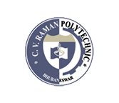C.V.Raman Polytechnic, BBSR

**Department of Civil Engineering**

**Product development, Consultancy, Manufacturing contracts, testing contracts :**

Following table shows Product development, Consultancy, Manufacturing contracts, testing contracts details.

## Product Development, Consultancy, Manufacturing contracts and testing contracts

|  |  |  |  |  |
| --- | --- | --- | --- | --- |
| **Sr. No** | **Item** | **Details** | **Year** | **Revenue (Rs.)** |
| 1 | **Product Development** | Updated version of the web site has been designed. | 2017-18 | 5000/- |
| 2 | **Consultancy** | Consultancy services rendered to **Maulana Azad National Urdu University (MANUU)** for 15 days for conducting experiments on survey in civil engineering | 2019-20 | 2 lakhs |